Eating in prison

Workbook 2

Eating to be healthy

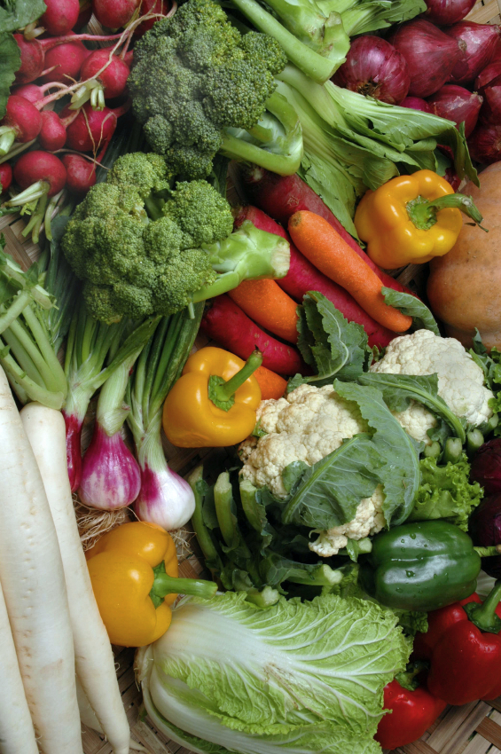

Contents page

How to use the workbook 3

Unit 1 What do you know about food? Do a quiz 5

Unit 2 Trying new food in prison 8

Unit 3 A prisoner talks – How I eat to keep fit 13

Unit 4 A doctor talks – Eating well in and out of prison 17

Unit 5 What’s in the food we eat? 20

End of workbook check 34

Answers 35

How to use the workbook

This workbook has activities on
- reading
- writing
- grammar
- vocabulary
You need a pen or pencil.

Do the activities then check your answers using the Answers pages at the back of the workbook.

Sometimes there will be a Glossary for new words. A glossary is a very short dictionary that explains the meanings of new words.

There is sometimes some information to read:

Information
If you see a box like this, read the information carefully. It will help you with the next task.

Sometimes you have to do some work outside your cell:

If you see something in a box like this, it means you have to do something outside your cell. For example, maybe you will have to;
- ask someone a question
- check something with your landing officer
- read something
- find or get something

Eating in Prison – Eating to be healthy: in and out of prison.
This workbook will help you learn more English about healthy food and eating in prison. You will learn new words. This will help you when you are reading or talking about eating well to stay healthy.
Learning goals

By the end of this book you will be able to:

    - understand and use new words to talk about food and eating
    - make short sentences with the correct word order
    - read and understand short texts about food
    - use ‘should’ when you are giving advice
    - use language to compare things (eg. highest, lowest; more than, less than)
    - use the present perfect to talk about your experiences

Unit 1 Quiz 1: What do you know about food?

1.1 Do you read food labels?

Look at this label on a jar of jam.  label | 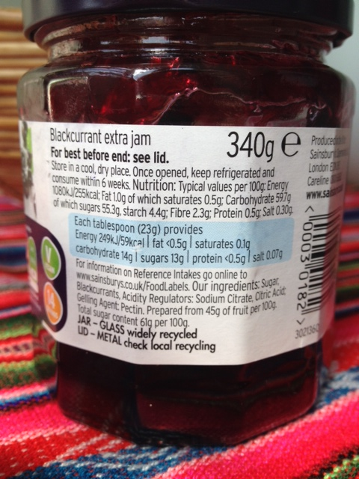 | 100g of jam contains:  255 calories (or kcal)

100g of jam has 255 kcal (calories)

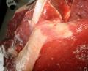 |  | 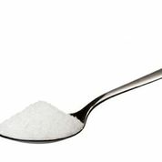
fat | energy  (we need this to move) | sugar
What are calories? Tick the correct sentence a, b or c then check your answer at the end of the book.

a) Calories tell us how much fat is in food.
b) Calories tell us how much energy the food gives us.
c) Calories tell us how much sugar is in the food.
Learn phrases to talk about healthy and unhealthy food.
Fruit and vegetables are good for us but too much sugar is bad for us.
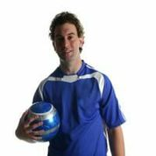

1.2 True or False food quiz.

Quiz 1 What do you know about food?  e.g. Fish oil is very healthy.  1. Eating 2000 calories each day is good for a woman.  2. Eating 3000 calories each day is good for a man.  3. Food calories we don’t use become fat in our bodies.  4. Breakfast is a small meal and is not so important.  5. Brown bread and white bread are equally healthy.  6. It is good to eat 3 lots of fruit and vegetables every day.  7. Fruit does not have any sugar.  8. Chips have more calories than rice.  9. Our bodies need salt to be healthy.  10. More than 3 teaspoons of sugar a day is not good for us. | True or False?  T / F  1. T / F  2. T / F  3. T / F  4. T / F  5. T / F  6. T / F  7. T / F  8. T / F  9. T / F  10. T / F
Check your answers at the end of the workbook.
Your score: 8 – 10 correct. Well done! You know a lot about food.
5 – 7 correct. Quite good. You know quite a lot.
0 – 4 correct. Not so good but now you can learn more!

1.3 Look at the quiz answers again. Put each food word below into the correct box to say if it is healthy (good for you) or unhealthy (bad for you).

healthy | unhealthy
 | e.g. salt (if we eat too much)
sugar fruit vegetables breakfast rice white bread brown bread salt chips

1.4 Look at these sentences and practise your verb grammar. Choose the correct verb for the sentence ‘is’ or ‘are’.

e.g. a) Sugar is / are bad for you. is

b) Chips is / are tasty but not very healthy.
c) Rice is / are healthy, especially brown rice.
d) Vegetables is / are good for you.
e) Salt is / are OK in small amounts.
f) Brown bread is / are healthier than white bread.
g) Fruit is / are good for you.
h) Breakfast is / are good for us.

Check your answers and your grammar.

Unit 2 Trying new food in prison

This is Anita. She has tried new food in prison. | 

Write down the names of any new food you have eaten in prison.
...............................................................................................................................

...............................................................................................................................

2.1 Read about Anita.

Trying new food in prison
‘My name’s Anita. I’ve been inside for a year. It’s not easy. Lots of things in my life have changed - including the food. It’s not what I cook at home or eat in my country. But there’s not much choice, is there? You have to eat it or go hungry. I haven’t eaten much British food before – just fish and chips. That was OK
I’ve decided to try new things. I think you need to try everything once, don’t you? If you don’t like it, don’t eat it again. Actually, I’ve eaten a few things I really like. Jacket potatoes are nice and cottage pie but I don’t like gammon.
Indian food is new for me. We don’t eat Indian food in my country but I’ve tried curry and now I really like it. Maybe one day I’ll have a go at making some of the food myself.
I miss my own food but I’m glad I’ve tried some new things here. It’s been good for me.’

2.2 Anita talks about different food. What do these words mean?

Tick the correct meaning a) or b). Use a dictionary to help if you have one.

e.g. breakfast  1. chips  2. jacket potatoes  3. cottage pie  4. gammon  5. curry | a) meal in morning  a) fried potatoes  a) cooked in water  a) made with chicken  a) meat from a pig  a) a hot, spicy sauce | b) meal in afternoon  b) crisps  b) cooked in the oven  b) beef and potato on top  b) fish  b) rice and vegetables
Check your answers.

2.3 Improve your grammar. Learn how to talk about your experiences.

Anita talked about some of her experiences.
I haven’t eaten much British food before.
I’ve tried curry and now I really like it.
I’ve tried some new things here.

Information
Anita is talking about her life before today. She uses the present perfect.

I’ve eaten British food. = I have eaten British food.
I’ve tried some new things. = I have tried some new things.
I haven’t eaten British food. = I have not eaten British food.

We use 2 verbs - have + past participle of main verb

Yes  I’ve eaten British food.  I’ve tried curry. | No never  I haven’t eaten British food.  I haven’t tried curry.

2.4 Look at the foods below. Make sentences so that they are true for you.
e.g curry (yes) I’ve eaten curry before.
e.g. jacket potato (no, never) I’ve never tried jacket potato.

- Chinese food ..........................................................................................................
- gammon .................................................................................................................
- cottage pie ...............................................................................................................
- brown bread .............................................................................................................
- fish and chips ..........................................................................................................

Check the answers in the back of the book.

b. Now write some more sentences about food you have and haven’t eaten before.
1
2
3
4
5

Ask a friend or teacher to check your sentences

Unit 3 Keeping fit and healthy in prison. What do people do?

3.1 Read the questions about yourself and answer yes or no. Look at the photos to help you.

Do you use the gym? Yes / No  Do you try to stay healthy? Yes / No  Are you fit? Yes / No  Do you like tuna fish? Yes / No | Do you ever buy protein powder from the canteen? Yes / No  Do you eat beans or lentils? Yes / No

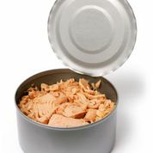 | 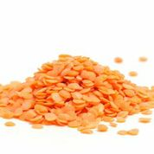 | 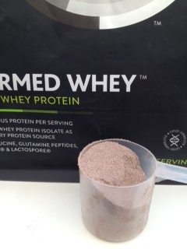
tuna | lentils | protein powder to build muscle

This is Jak. He tries to stay fit and healthy in prison.

 | 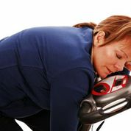
These men are fit. They can do lots of exercise and not get tired quickly. | This woman is unfit. She gets tired very quickly when she does exercise.
Are you fit or unfit?
3.2 Read about Jak and answer the questions.

How I eat to keep fit and healthy in prison
My name’s Jak. I like keeping fit and I use the gym here when I can. I did building work before so I was pretty fit. It’s a bit of a problem now trying to eat to stay fit, to be honest.
I bought protein powder from the canteen sheet but it’s not cheap! I don’t have much money so I try to choose the best food I can from the menu.
If there is tuna or chicken, I go for that - any meat or fish really but not if it’s fried. I look for food with beans - baked beans, kidney beans, or lentils or something like that because they have lots of protein too. I sometimes choose vegetarian food. Eggs are great and cheese is good but not too much because it’s got lots of fat.
Eating breakfast is very important. I would really like eggs for breakfast but we only get a breakfast pack. I’m always starving by lunchtime! I was active all day when I was working but not now, so I stay off the cakes and chips!

1. Jak was fit before he went into prison. T / F

2. Jak finds it difficult to eat healthily in prison. T/ F

3. Protein powder is very expensive. T / F

4. His favourite food is fried chicken. T / F

5. Lentils have lots of protein. T / F

6. Jak always eats eggs for breakfast. T / F

7. Choose the best meaning for the word ‘starving’ very tired /very hungry
3.3 Read the text again. Which 9 foods did Jak say are good to eat for fitness?

e.g. 1. tuna | 2. c.. | 3. m .
4. f. | 5. b. .b | 6. k b
7. l.. | 8. e | 9. c

3.4 How often … ?

How often do you eat the nine foods on the list above?

Information

every day  a few times a week/several times a week  twice a week  once a week  now and again  never | = 7 days a week  = 3 or 4 times a week  = 2 times a week  = 1 time a week  = sometimes  = 0
e.g. ‘I eat bread several times a week’
I eat lentils now and again.
Are the words ‘several times a week’ and ‘now and again’ in the middle of the sentence or at the end?

We use these words below to talk about how often we do things.

This sentence is wrong because the words ‘every day’ are in the wrong place.
I every day eat fish. x

This sentence is good English because the words are now at the end.

I eat fish every day.
a. The words in some of the sentences below are in the wrong order. Put a X by the ones in the wrong order and a next to the correct ones.

- eg. I now and again eat beans. x  - eg. I eat fish once a week.  - I have now and again eggs.  - I have several times a week chicken.  - I eat cheese twice a week. | - I have meat every day.  - I a few times a week eat chips.  - I eat tuna now and again.  - I eat lentils a few times a week.  - I have once a week cake.

Now check your answers

b. How often do you eat these foods? Write a sentence and put the time word in the right place.

e.g. bread I eat bread every day

- cakes ...........................................................................................................
- potatoes ......................................................................................................
- beans ..........................................................................................................
- chicken .......................................................................................................
- fish ..............................................................................................................
- vegetables ..................................................................................................
- cheese .........................................................................................................
- eggs ...........................................................................................................
Ask a friend or a teacher to check your answers.

Unit 4 – A doctor talks: Eating well in and out of prison
 | Try to stay healthy while you are in prison. Eating well is an important part of this. Read what a doctor says about eating good food.
4.1 Read the text below.

‘You should eat a balanced diet – that means a mix of different foods. It’s difficult when you can’t decide what food is on the menu but you should choose lots of different things from the menu each week. A good mixture of meat, fish, vegetables, salad, beans, rice, eggs, pasta and potatoes will give your body what it needs to be healthy. If possible, you should try to eat five fruit and vegetables every day.
You should eat oily fish like mackerel or sardines sometimes, if it is on your menu. You shouldn’t eat too many crisps or biscuits just a small amount each week and you should read the labels on the food you buy from the canteen sheet so you can choose healthy food. ’ (Adapted from NHS choices)
Glossary
oily (adj) = has lots of oil in it
diet (n) = what we usually eat
a small amount = a little bit
a mix (n) = lots of things together (the nouns mix and mixture have the same meaning)

a. What does ‘a balanced diet’ mean? Find the meaning in the text
............................................................................................................................CCheck your answer.
4.2 Giving advice

Information
Doctors often give advice. Advice means when someone tells you what they think you should do or how you should do something..

Read the what the doctor said again and fill in the missing words.
1) You ................... try to eat five types of fruit and vegetables every day.

e.g. You should eat a balanced diet.

3) You ......................... eat too many crisps or biscuits.
2) You ................. read the labels on the food you buy using the canteen sheet.

4.3 Read the sentences below. Tick the correct one on each line.

e.g a) You should read the labels. b) You should reading the labels. X
b is wrong because we don’t use – ing after should
1. a) You shouldn’t to eat too much sugar. | b) You shouldn’t eat too much sugar.
2. a) You should ate a balanced diet. | b) You should eat a balanced diet.
3. a) You should choose lots of different things from the menu. | b) You should choosing lots of different things from the menu.

Check your answers..
4.4 Grammar practice – asking for advice.

You want some advice - maybe from the doctor or someone in the prison.  Learn how to use the correct word order when you ask for advice. | 
Choose the question that is in correct English.

1. “I want to stop smoking. What I should do?”
2. “I want to stop smoking. What I must do?”
3. “I want to stop smoking. What should I do?”

Check your answer.

4.5 Five prisoners have a problem. Match the problem with the advice they get.

I get headaches when I read. | You should fill in an app.
I can’t understand words on the canteen sheet. | You should talk to a landing officer.
I want to join the gym. | You should see an optician.
I want an app to see the doctor. | You should talk to a Listener.
I feel sad and lonely. | You should ask your teacher.

Unit 5 What is in the food we eat?

5.1 Vocabulary – nutrients

The food we eat contains things called nutrients. Our body needs nutrients to be healthy.
a. Look at the names of five nutrients and read about how they help us.

Glossary
1. protein | Protein helps muscles and new body cells to grow.
2. carbohydrates | Carbohydrates give us energy to move.
3. fat | We need fat to protect parts inside our body, for example, our heart, but only a small amount of fat is needed.
4. fibre | We need fibre to keep our stomach and food digestion healthy and we can go to the toilet often. We only get this from plants.
- vitamins and minerals | We need small amounts of these, for example, to make bones and teeth strong, make new red blood cells and keep our eyes healthy.

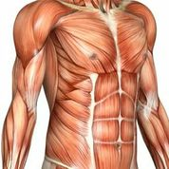 | 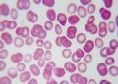 | 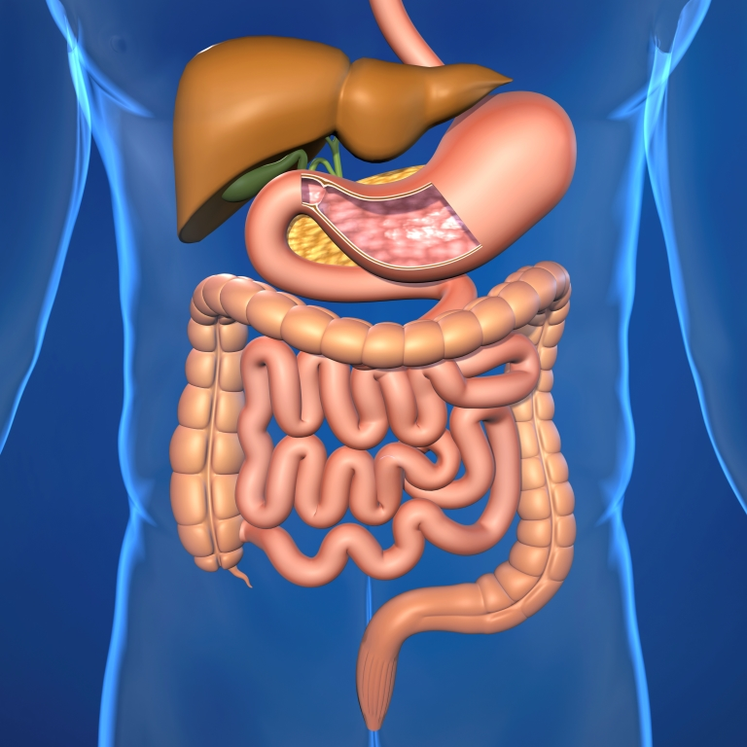 | 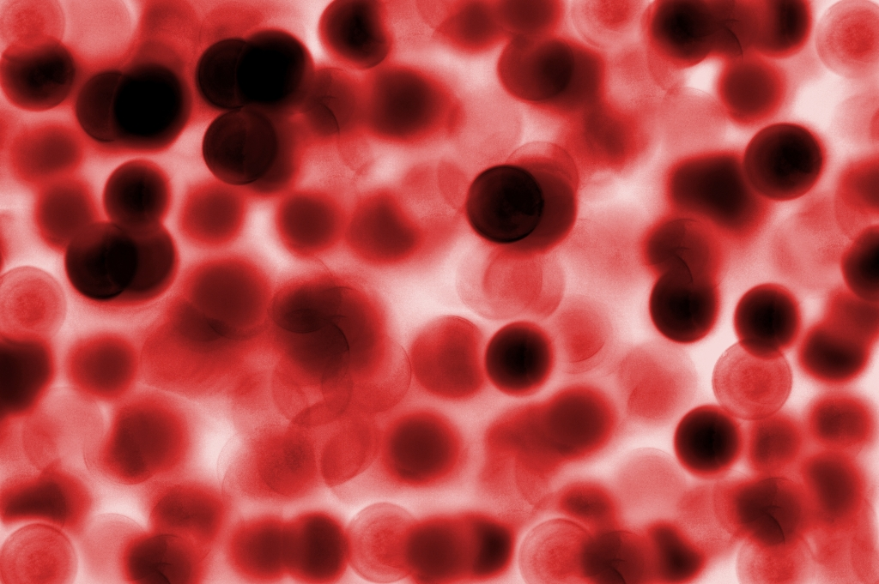
muscles | body cells | digestion | blood cells

b. Now answer the questions about nutrients.
e.g. Which nutrient protects parts inside our body? fat

1) How much fat do we need? ……………………………………………………;
.........................................................................................................................
2) Why are carbohydrates good for us? ...........................................................
………………………………………………………………………………………...
3) Which nutrients give us strong bones and healthy eyes? ..............................
…………………………………………………………………………………………
4) Which nutrient helps muscle grow? …….......................................................
…………………………………………………………………………………………
5) What is good for digestion? ........................................................................

Now check your answers.

5.2 Can you do this crossword? Find the words from the text above.
 |  |  | 1
 |  |  |  |  | 2
3
 |  |  |  |  |  |  |  |  |  |  |  |  | 4

Across
1. Cheese is high in ..........
3. Fish has lots of ..........
7. Fibre is important for our .......... system
8. Eat lots of protein if you want big .......... !
 |  |  |  |  |  |  |  | 5 |  |  | 6
 |  |  |  |  | 7
 |  |  |  |  |  |  |  |  |  |  | 8 |  |  | 9

Down
1. Breakfast cereals contain ..........
2. Pasta and rice have a lot of ..........
4. .......... bread is better for you
5. .......... and fish are high in protein
6. Fruit is full of .......... C
9. Vitamins and minerals are important for us to make new red blood ..........
Check your answers.

5.3 Food labels and nutrients
Do you ever read the labels on the food you buy? Have a look at some information about nutrients in food.

sugar  100g =  400 calories  0g protein  0g fibre  0g fat  100g carbohydrate | baked beans  100g =  79 calories  4.7g protein  3.7g fibre  0.2g fat  12.9g carbohydrate | tuna fish  100g =  113calories  27g protein  0g fibre  0.5g fat  0g carbohydrate | carrots  100g =  41 calories  0.9g protein  2.8g fibre  0.2g fat  10g carbohydrate
apple  1 apple =  52 calories  0.3g protein  2.4g fibre  0.2g fat  14g carbohydrate | chicken  100g=  172 calories  21g protein  0g fibre  9g fat  0g carbohydrate | medium banana  1 banana=  89 calories  1.1g protein  3.1g fibre  0.3g fat  23g carbohydrate | white rice  100g=  148calories  3.2g protein  0.4g fibre  0.4g fat  32g carbohydrate
*Source:USDA for Wikipedia

100g the highest/  the most  0g the lowest /  the least | Information  We can compare things using the words  ‘the highest’ and ‘the lowest’, ‘the most’ and ‘the least’.  Sugar has the highest amount of carbohydrate.  Tuna and chicken have the lowest amount.

Look at the food labels and answer the questions below.
e.g. Which food has the highest amount of carbohydrate? sugar

- Which food has the lowest amount of fibre?
- Which food has the highest amount of protein?
- Which food has the most fat?
- Which food has the highest number of calories?
- Which food has the lowest amount of protein?
Check your answers.
5.4 Comparing things more (......) than / less (.......) than.

baked beans  100g =  79 calories  4.7g protein  3.7g fibre  0.2g fat  12.9g carbohydrate | tuna fish  100g =  113 calories  27g protein  0g fibre  0.5g fat  0g carbohydrate | Information  Tuna fish has less fibre than baked beans.  Baked beans have less protein than tuna.
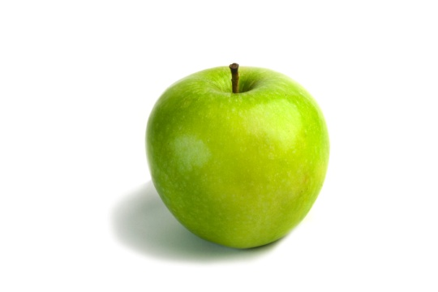
Look at the food labels above again. True or false?

1. Sugar has more carbohydrates than baked beans. T / F
2. Rice has more calories than carrots T / F
3. Bananas have more fibre than apples. T / F
4. Tuna has less protein than rice. T / F
Check your answers.

5.5 Make some comparisons yourself using ‘more...than’ or ‘less...than’

e.g. Chicken has more protein than rice. (protein)

- Sugar...............................................................................tuna. (protein)
- Apples ............................................................................bananas. (fibre)
- Baked beans ..................................................... carrots. (carbohydrate)
- Chicken .....................................................................rice. (fat)
- Rice ..........................................................................sugar. (carbohydrate)
- Baked beans ....................................................................tuna. (fibre)
Check your answers.

Things I can do

I can do this

? I need more practice

I can.... | √  ?
I can read and understand food labels.

I can understand words about food, nutrients and healthy eating.

I can make sentences about food I eat using the adverbs ‘now and again’, ‘a few times a week’ ‘once a week’ and ‘twice a week’.

I can write some sentences about food I have eaten and food I haven’t eaten in prison using the present perfect.

I can understand and use ‘should’ and ‘shouldn’t’.

Answers
Unit 1 – What do you know about food?
1.1 (b) Calories tell us how much energy food gives us.

1.2 Quiz
- T – about 2000 calories is good for a woman
- F – about 2500 is good for a man
- T – the body stores the calories we don’t use as fat..
- F – breakfast is very important.
- F – brown bread has more fibre, vitamins and minerals than white bread.
- T – but it is best to try and eat 5 – especially vegetables.
- F – all fruit has sugar, some have a lot..
- T – chips have more calories because they are fried in oil.
- T – but only 6g each day is healthy.
- T – more than three teaspoons of sugar each day is not good.
1.3
healthy  fruit rice vegetables  wholemeal bread breakfast | unhealthy  white bread salt ( a lot) chips

1.4 b) are c) is d) are e) is f) is g) is h) is

Unit 2 – Trying new food in prison.

2.2 1 (a) 2 (b) 3 (b) 4 (a) 5 (a)

2.4 You can use the words ‘tried’ or ‘eaten’ or ‘had’. They are all correct.

- I’ve eaten Chinese food before. I haven’t tried/eaten Chinese food.
- I’ve eaten/tried gammon. I’ve never tried gammon.
- I haven’t tried/eaten cottage pie. I have eaten cottage pie before.
- I haven’t tried/eaten brown bread. I have eaten brown bread before.
- I’ve eaten/tried fish and chips. I’ve never had fish and chips before.
Unit 3 – Keeping fit and healthy in prison. What do people do?

3.2
1. T (yes, he was a builder)
2. T (he says it’s a bit of a problem trying to stay fit)
3. T (he says it’s not cheap)
4. F ( he says he goes for chicken, but not if it’s fried)
5. T
6. F ( he says he only gets the breakfast pack)
7. starving means very hungry

3.3
2. chicken 3. meat 4. fish 5. baked beans 6. kidney beans 7. lentils 8. eggs 9. cheese

3.4
- X I have eggs now and again
- X I have chicken several times a week
- Correct
- Correct
- X I eat chips a few times a week.
- Correct
- Correct
- X I have cake once a week.

Unit 4 - A doctor talks – eating well in and out of prison.

4.1 a mix of different foods

4.2
- You should try and eat five fruit and vegetables every day.
- You should read the labels on the food you buy from the canteen sheet.
- You shouldn’t eat too many crisps or biscuits.

4.3
1. b is correct. a You shouldn’t to eat too much sugar. (no ‘to’ with should)
2. b is correct. a You should ate (past tense) a balanced diet.
3. a is correct. b You should choosing (no ing) lots of different things from the menu.

4.4 Answer 3 is correct
1. What I should do? The words are in the wrong order – ‘I should’ not ‘should I’.
2. What I must do? The words are in the wrong order and we don’t use ‘must’ for advice.

4.5
I get headaches when I read. | You should see an optician.
I can’t understand words on the canteen sheet. | You should ask your teacher
I want to join the gym. | You should fill in an app.
I want an app to see the doctor. | You should talk to a landing officer
I feel sad and lonely. | You should talk to a Listener

Unit 5 What’s in the food we eat?

5.1
- a little bit of fat
- they give us energy to move or do exercise
- vitamins and minerals
- protein
- fibre

5.2
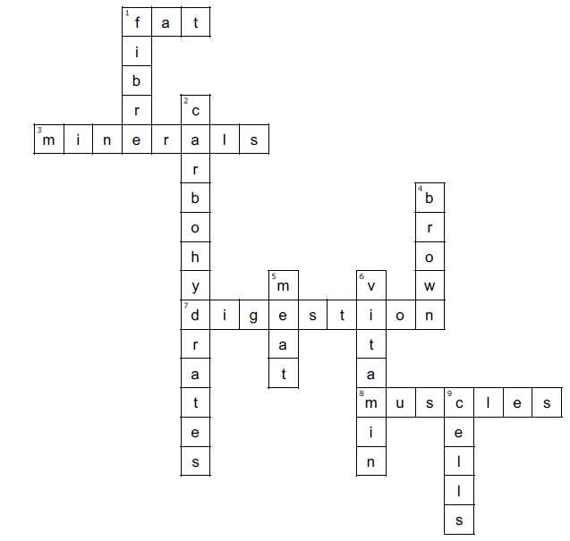
5.3
- sugar, chicken, tuna 2. tuna fish
- chicken 4. sugar
- sugar

5.4 1. T 2. F 3. T 4. F

5.5
1. Sugar has less protein than tuna
2. Apples have less fibre than bananas.
3. Baked beans have more carbohydrates than carrots.
4. Chicken has more fat than rice.
5. Rice has less carbohydrate than sugar.
6. Baked beans have more fibre than tuna

